Week 9 – Submit Task

Question 1

(VCAA Algorithmics Examination 2021)

You must also explain your answer below.

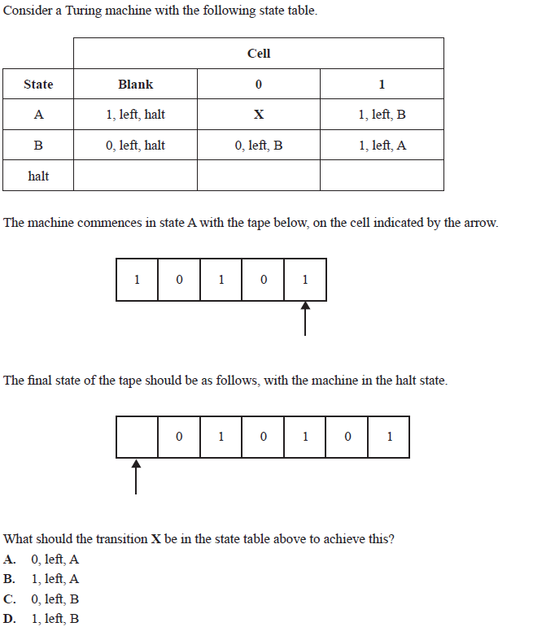

Each of the following questions is worth 2-3 marks. Provide a short written response.

Question 2

Explain the concept of a Turing machine and its components. How does it simulate the behavior of a computer algorithm?

Question 3

Define undecidability in the context of computer science. Provide an example of an undecidable problem and explain why it is impossible to solve algorithmically.

Question 4

Define the halting problem and explain why it is considered an undecidable problem. What are the consequences of its undecidability for the limits of computation?

Question 5

Discuss the relationship between the halting problem and Gödel's incompleteness theorems. How do they both relate to the concept of undecidability?